SCHOOL OF COMPUTER SCIENCE AND ARTIFICIAL INTELLIGENCE |  |  |  |  | DEPARTMENT OF COMPUTER SCIENCE ENGINEERING
Program Name:B. Tech |  |  |  | Assignment Type: Lab |  |  | Academic Year:2025-2026
Course Coordinator Name |  |  |  | Dr. Rishabh Mittal
Instructor(s)Name |  |  |  | Mr. S Naresh Kumar  Ms. B. Swathi  Dr. Sasanko Shekhar Gantayat  Mr. Md Sallauddin  Dr. Mathivanan  Mr. Y Srikanth  Ms. N Shilpa  Dr. Rishabh Mittal (Coordinator)  Dr. R. Prashant Kumar  Mr. Ankushavali MD  Mr. B Viswanath  Ms. Sujitha Reddy  Ms. A. Anitha  Ms. M.Madhuri  Ms. Katherashala Swetha  Ms. Velpula sumalatha  Mr. Bingi Raju  Mr. G. Kranthi
Course Code |  |  | 23CS002PC304 | Course Title |  | AI Assisted Coding
Year/Sem |  |  | III/I | Regulation |  | R23
Date and Day  of Assignment |  |  | Week 6 - Thursday | Time(s) |  | 23CSBTB01 To 23CSBTB52
Duration |  |  | 2 Hours | Applicable to  Batches |  | All Batches
AssignmentNumber:12.4 (Present assignment number)/24(Total number of assignments)
 | Q.No. | Question |  |  |  |  |  | ExpectedTime  to complete
 | 1 | Lab 12 – Algorithms with AI Assistance – Sorting, Searching, and Optimizing Algorithms  Lab Objectives  - Apply AI-assisted programming to implement and optimize sorting and searching algorithms.  - Compare different algorithms in terms of efficiency and use cases.  - Understand how AI tools can suggest optimized code and complexity improvements.  Learning Outcome  After completing this assignment, students will be able to:  - Implement classical algorithms with AI assistance  - Compare algorithm efficiency using real-world scenarios  - Understand when optimization is necessary  - Critically evaluate AI-generated suggestions instead of blindly accepting them |  |  |  |  |  | Week 6

Task 1: Bubble Sort for Ranking Exam Scores

Scenario
You are working on a college result processing system where a small list of student scores needs to be sorted after every internal assessment.

Task Description
- Implement Bubble Sort in Python to sort a list of student scores.
- Use an AI tool to:
  - Insert inline comments explaining key operations such as comparisons, swaps, and iteration passes
  - Identify early-termination conditions when the list becomes sorted
  - Provide a brief time complexity analysis

Expected Outcome
- A Bubble Sort implementation with:
  - AI-generated comments explaining the logic
  - Clear explanation of best, average, and worst-case complexity
  - Sample input/output showing sorted scores
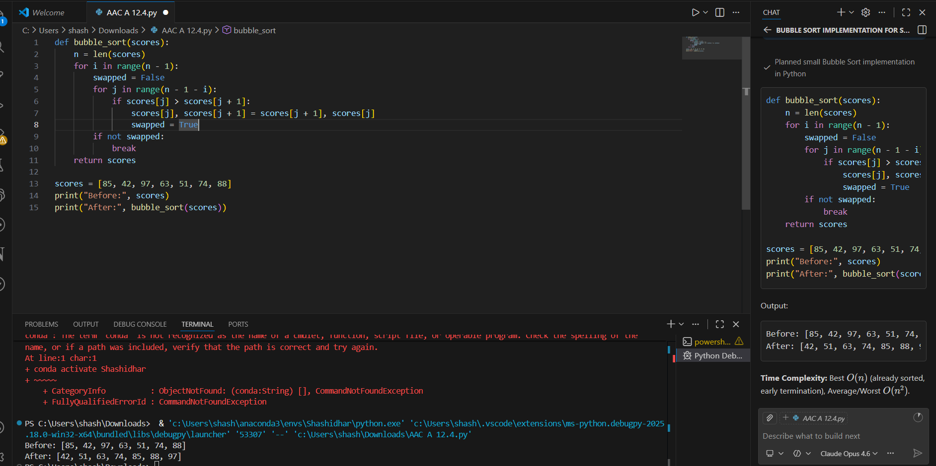

Task 2: Improving Sorting for Nearly Sorted Attendance Records

Scenario
You are maintaining an attendance system where student roll numbers are already almost sorted, with only a few late updates.

Task Description
- Start with a Bubble Sort implementation.
- Ask AI to:
  - Review the problem and suggest a more suitable sorting algorithm
  - Generate an Insertion Sort implementation
  - Explain why Insertion Sort performs better on nearly sorted data
- Compare execution behavior on nearly sorted input

Expected Outcome
- Two sorting implementations:
  - Bubble Sort
  - Insertion Sort
- AI-assisted explanation highlighting efficiency differences for partially sorted datasets
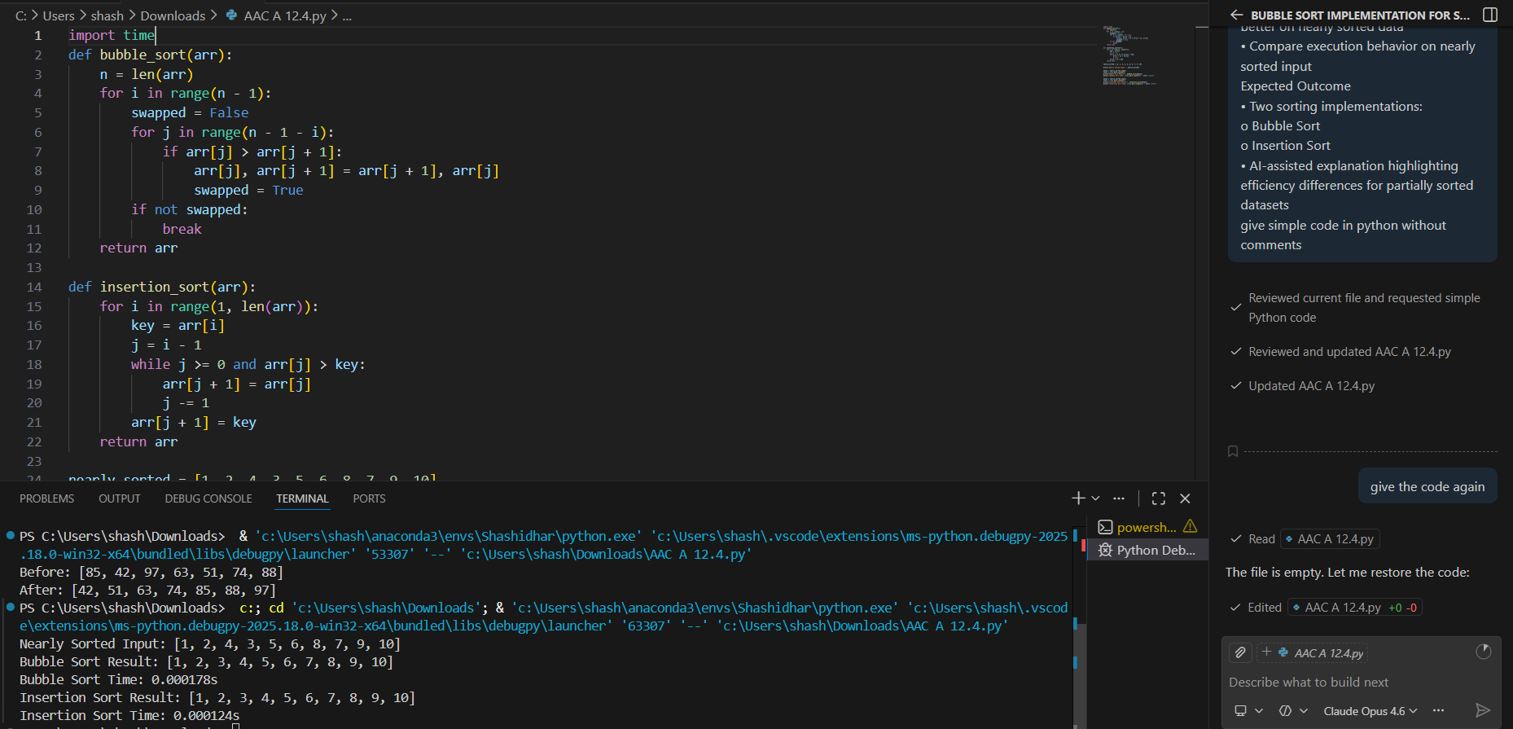
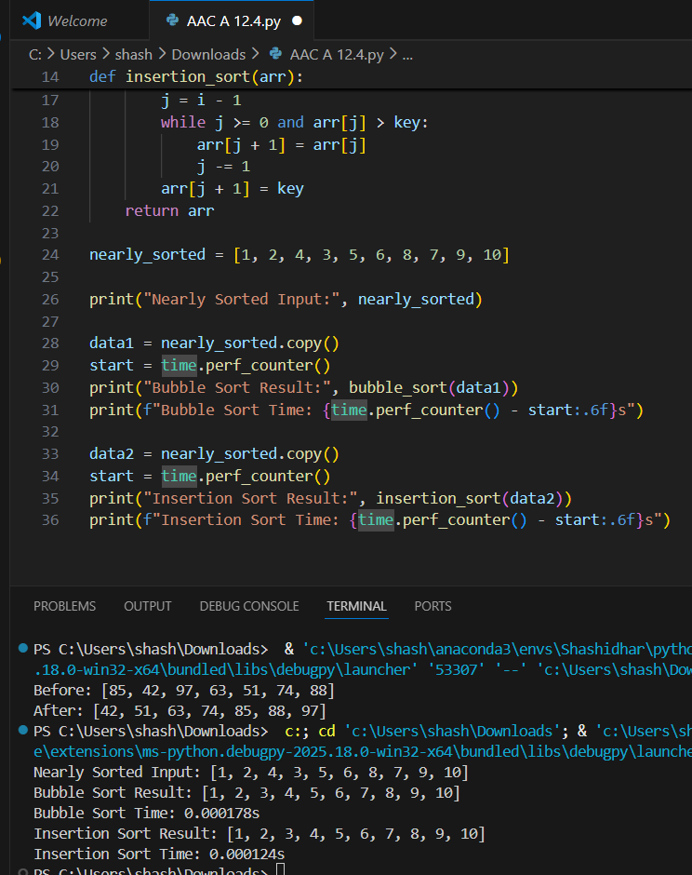

Task 3: Searching Student Records in a Database

Scenario
You are developing a student information portal where users search for student records by roll number.

Task Description
- Implement:
  - Linear Search for unsorted student data
  - Binary Search for sorted student data
- Use AI to:
  - Add docstrings explaining parameters and return values
  - Explain when Binary Search is applicable
  - Highlight performance differences between the two searches

Expected Outcome
- Two working search implementations with docstrings
- AI-generated explanation of:
  - Time complexity
  - Use cases for Linear vs Binary Search
- A short student observation comparing results on sorted vs unsorted lists
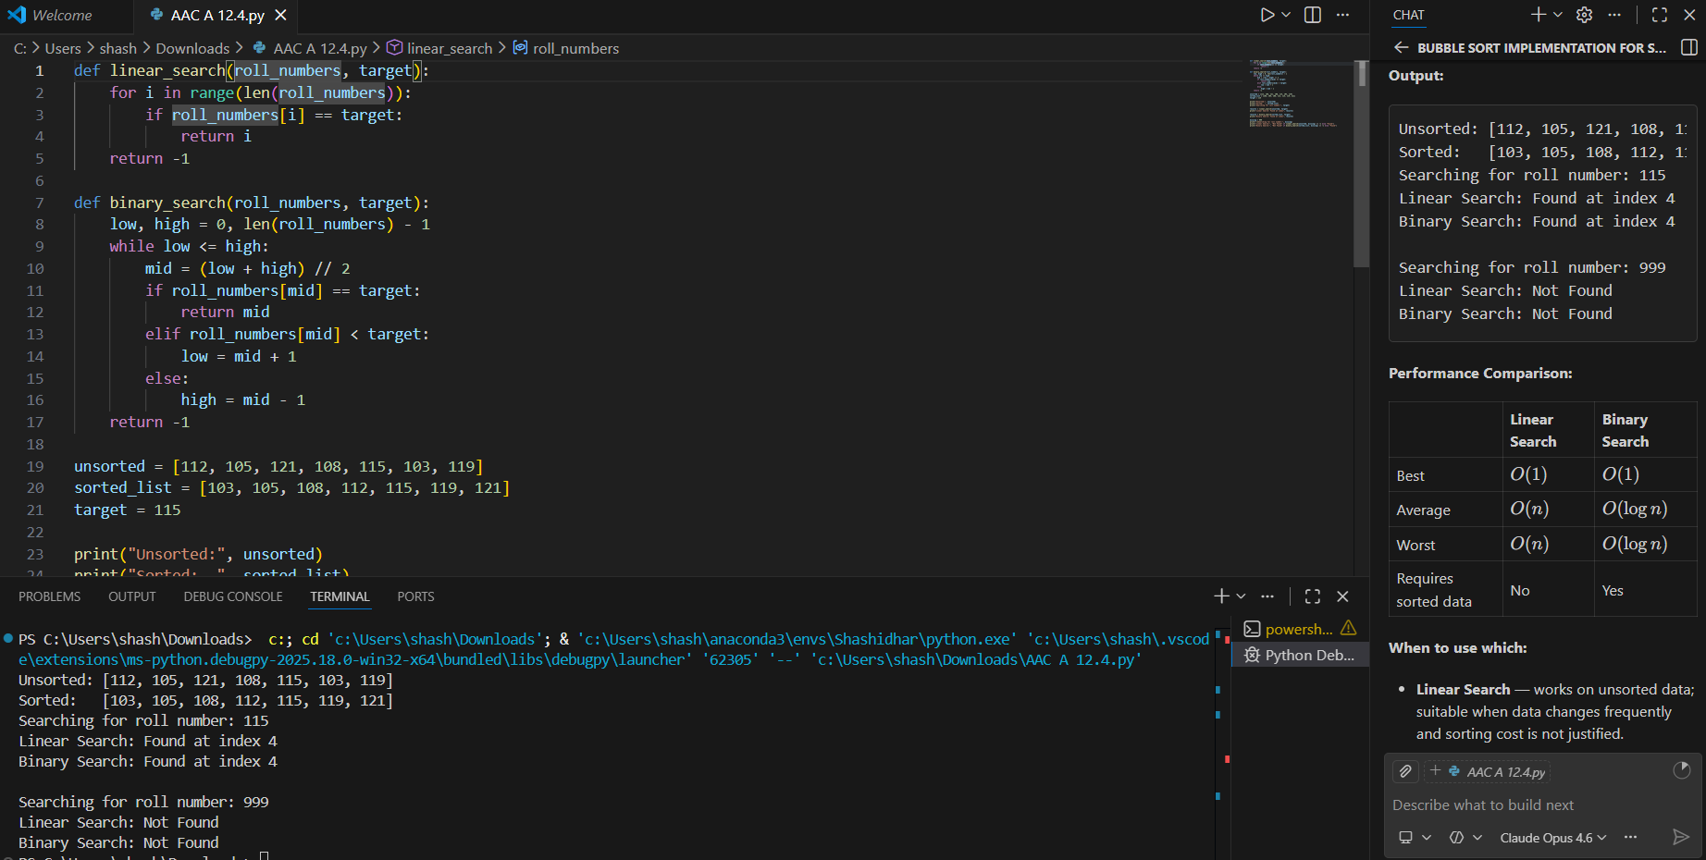
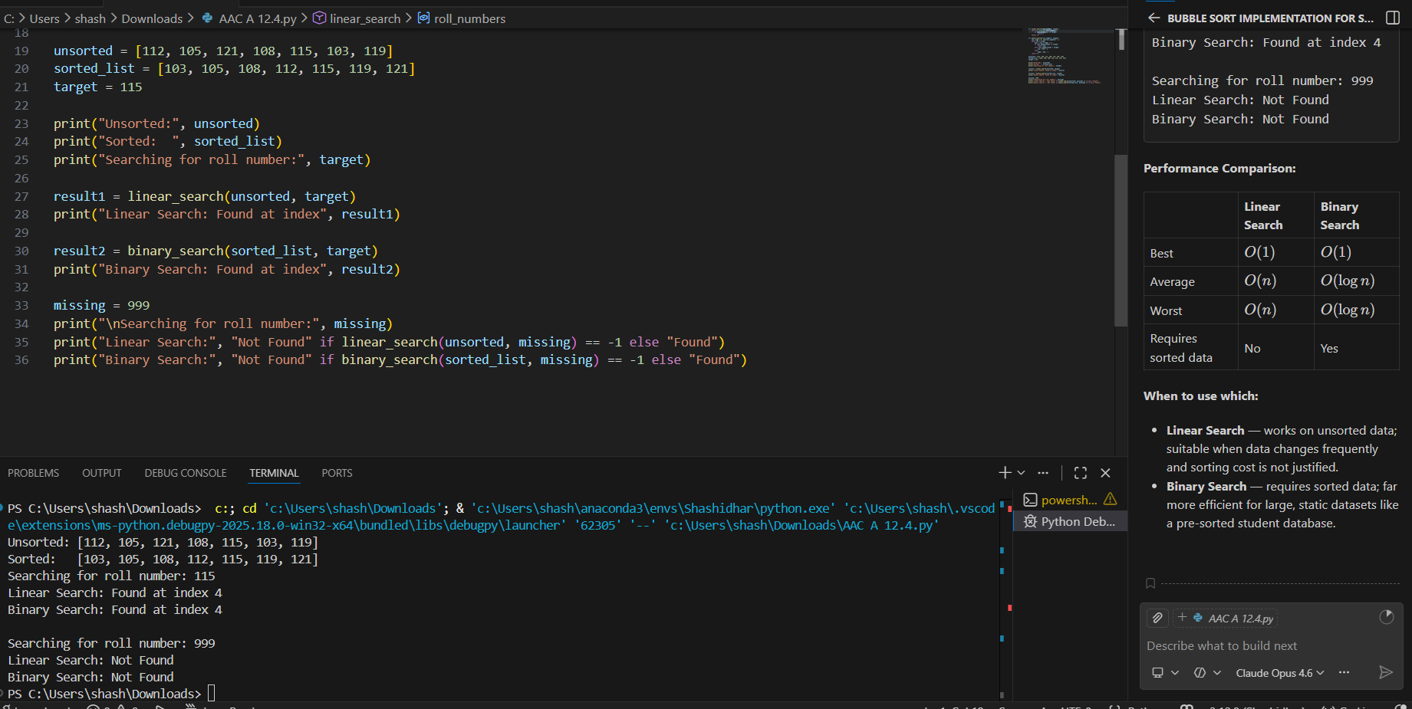

Task 4: Choosing Between Quick Sort and Merge Sort for Data Processing

Scenario
You are part of a data analytics team that needs to sort large datasets received from different sources (random order, already sorted, and reverse sorted).

Task Description
- Provide AI with partially written recursive functions for:
  - Quick Sort
  - Merge Sort
- Ask AI to:
  - Complete the recursive logic
  - Add meaningful docstrings
  - Explain how recursion works in each algorithm
- Test both algorithms on:
  - Random data
  - Sorted data
  - Reverse-sorted data

Expected Outcome
- Fully functional Quick Sort and Merge Sort implementations
- AI-generated comparison covering:
  - Best, average, and worst-case complexities
  - Practical scenarios where one algorithm is preferred over the other
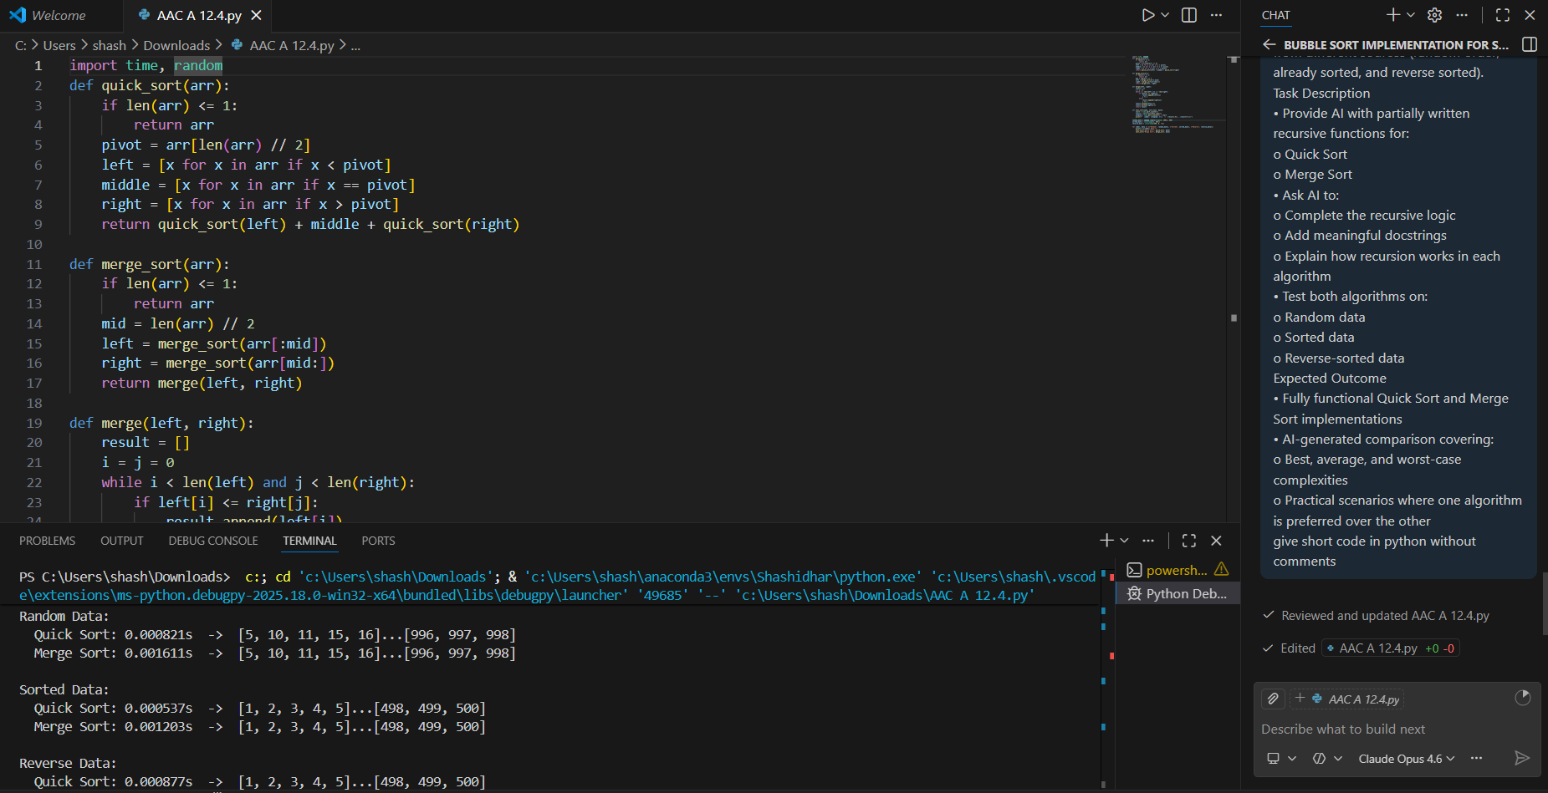
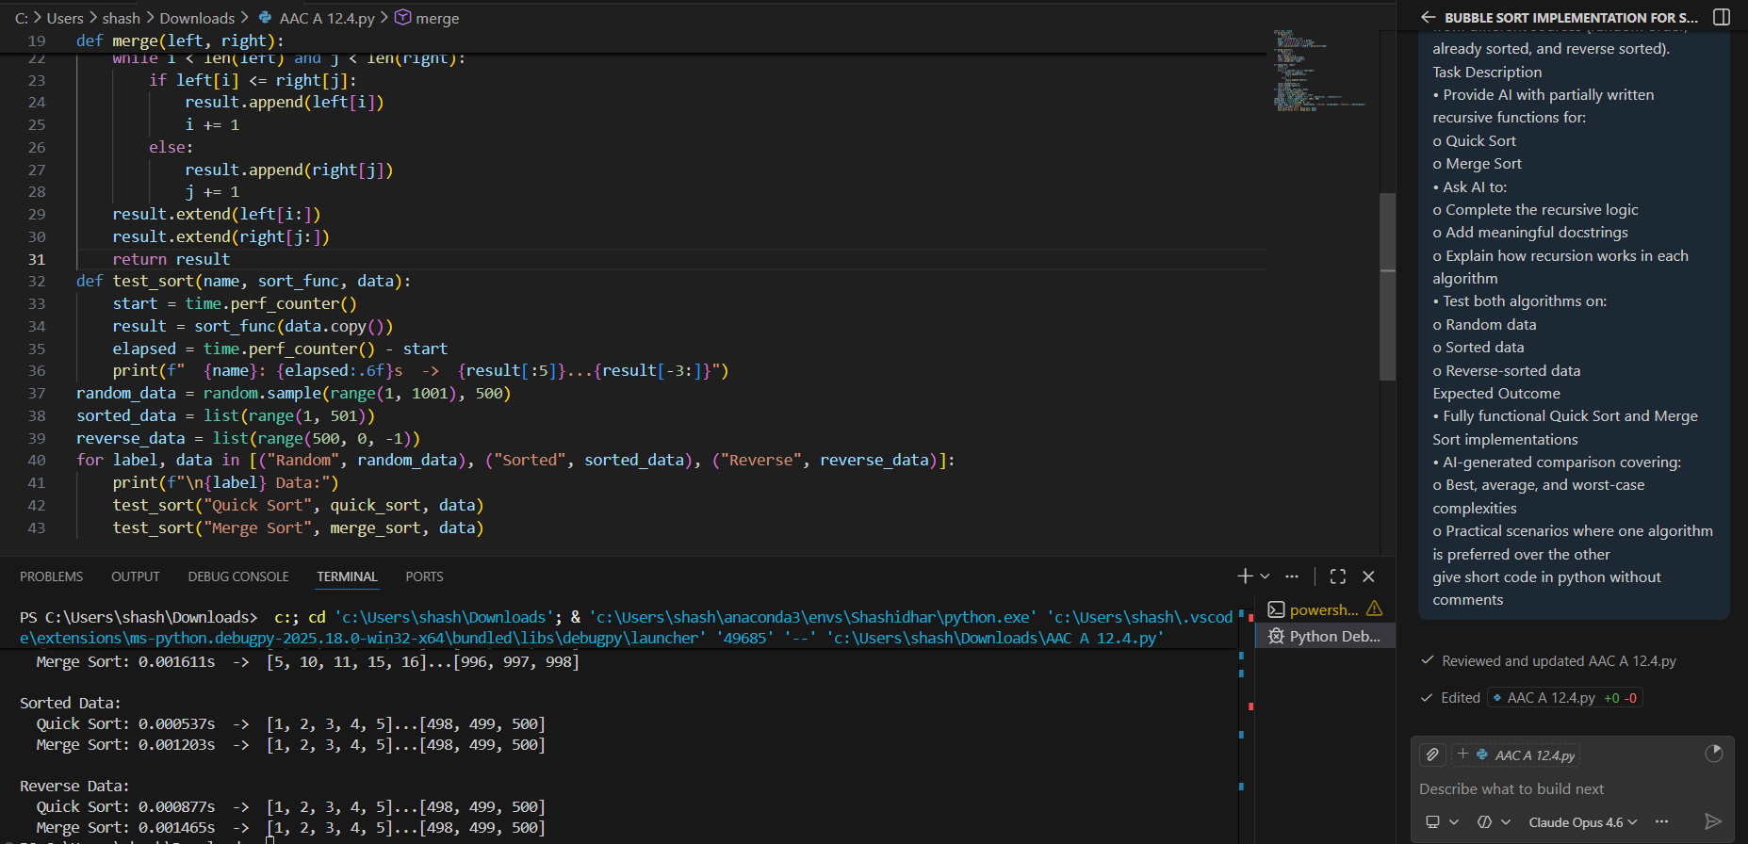

Task 5: Optimizing a Duplicate Detection Algorithm

Scenario
You are building a data validation module that must detect duplicate user IDs in a large dataset before importing it into a system.

Task Description
- Write a naive duplicate detection algorithm using nested loops.
- Use AI to:
  - Analyze the time complexity
  - Suggest an optimized approach using sets or dictionaries
  - Rewrite the algorithm with improved efficiency
- Compare execution behavior conceptually for large input sizes

Expected Outcome
- Two versions of the algorithm:
  - Brute-force (O(n²))
  - Optimized (O(n))
- AI-assisted explanation showing how and why performance improved
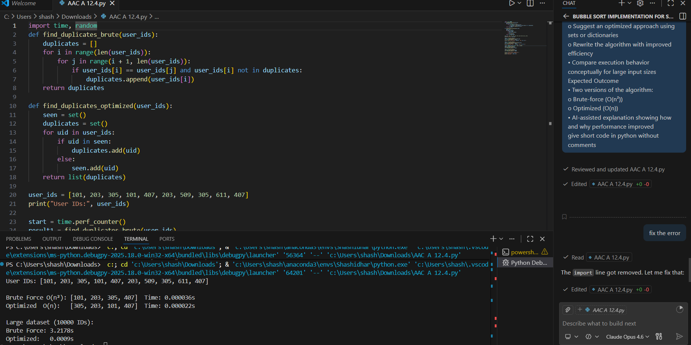

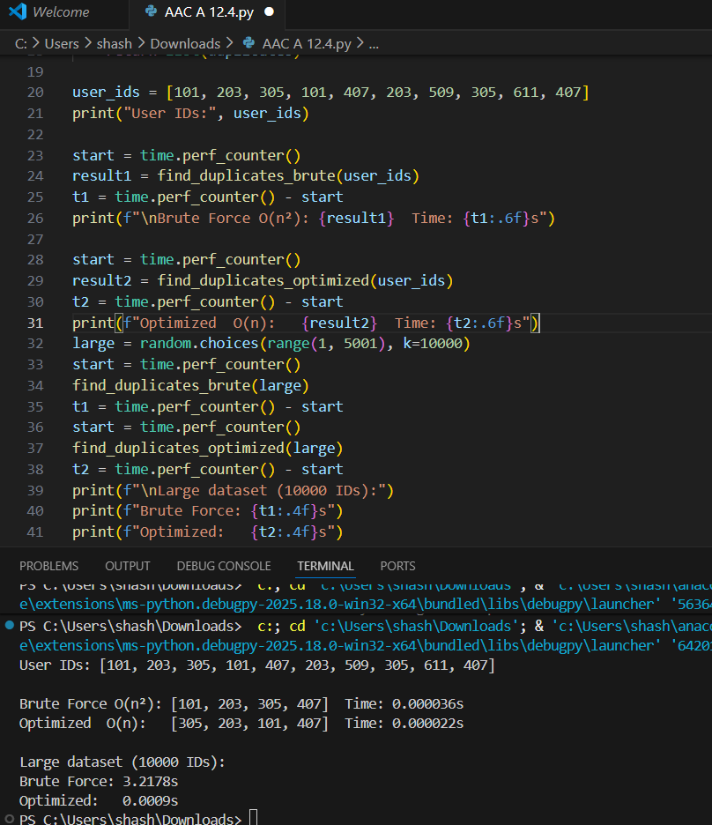
Note: Report should be submitted a word document for all tasks in a single document with prompts, comments & code explanation, and output and if required, screenshots

